MIFOS

**UPI in India**

Digital Impact Alliance

horizontal line

# 

# Introduction

In April 2016, National Payments Corporation of India with the support of Reserve Banks of India(RBI) and Indian Banks Association (IBA) launched an initiative known as Unified Payments Interface (UPI). It is because of UPI that online transactions have become much easier and online payments have increased by 200% in India.

# What is UPI?

Unified Payments Interface (UPI) is a system that powers multiple bank accounts into a single mobile application (of any participating bank), merging several banking features, seamless fund routing & merchant payments into one hood. It also caters to the “Peer to Peer” collect request which can be scheduled and paid as per requirement and convenience.

# 

# How Does it Work?

UPI is built on top of a platform called the National Financial Switch. With the help of this platform, it is possible to transfer money from one account of one bank to another account of another bank.

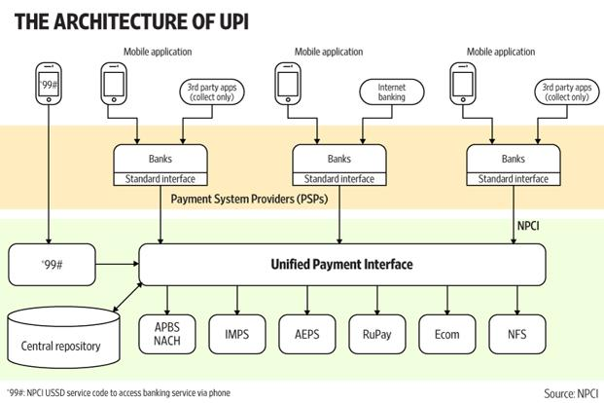

# How can a Normal User use UPI?

Users can download the BHIM UPI app to their smartphones and link their bank accounts to it. Users can also dial *99# to make transactions.

# But is it Making Any Difference?

Simply, YES. According to data released by the National Payments Corporation of India (NPCI), which runs the UPI platform, UPI transactions surged to 9.2 million in May from 6.9 million in April and 92,000 in August. The total value of UPI transactions shot up to Rs 27 billion in May from Rs 7 billion in December, a month after the government demonetised high-value banknotes.

# Why is UPI growing so Popular?

Firstly, UPI is very simple to use. E-wallets involve multiple legs in a transaction whereas UPI is easy and straight foward to use. Another reason is that UPI does not require any KYC of any sort, if you are an Indian with a bank account, you are good to go. Moreover features like virtual addresses and 2 factor authentication make it customer favourite.

# Is it a Mobile-wallets killer?

There has been a lot of speculation that UPI is the beginning of the end for mobile wallets. In my view, that is a very premature and uninformed contention, given that mobile wallet companies in India have more customers than any of the existing bank supported apps combined. Although, UPI holds tremendous potential and anything can happen.

Frequently Asked Questions

## What are the important features of UPI?

It is accessible 24*7 and 365 days. A single app can be used for different bank accounts. Customers can make virtual addresses, these virtual addresses of the customer for Pull & Push provide for incremental security with the customer not required to enter the details such as Card no, Account number; IFSC etc.

## What are Virtual Addresses?

UPI ID or VPA is a Virtual payment address which is used in place of bank account details for the fund transfer. This address is unique to every user. It is very flexible and you can change it. Since it is not your actual payment address but act as the payment address (bank account details), It is called the virtual payment address or VPA. The UPI ID resembles the email ID.

## How secure is UPI?

Every UPI transaction, irrespective of which app, goes through a leg of transaction which requires a (public key infrastructure) PKI-based encryption key usage and validation with the National Payments Corporation of India of the fingerprint of the mobile device and validation of a UPI PIN using a hardware security module, once in a complete end-to-end transaction.

## How Different is UPI from Mobile Wallets?

UPI do direct bank to bank money transfer but wallets act as an intermediary between two bank accounts i.e. you recharge your wallet from your bank account to use any services that a wallet provides. Also, UPI allows you to transact up to Rs. 1,00,000/- and in the case of wallets you can only store up to Rs. 10,000 (For non KYC customer).